Weather Lab # Rate at Which Surface Layers Heat or Freeze
Date: Name & Partners:
Purpose: To test how different ground or water layers respond to temperature changes of heating or cooling.
Hypothesis: I predict that ________________’s temperature will take the longest to heat or cool and ______________’s temperature will take the shortest amount of time to heat or cool.
Materials:
-thermometers -pencil crayons -samples: soil, water, gravel, and sand
-lab report -plastic cups -pencil
Procedure:
- Gather samples in a plastic cup: soil, sand, water and gravel
- Place a thermometer in each sample and record the temperature at room temperature
- Record outside present temperature
- Place samples outside in direct sunlight (ideally) for 10-60 minutes.
- Observe the temperature of each sample and record and illustrate thermometers
- Write observations and explain results
- Refer to your original hypothesis, confirm or refute whether correct or not and why in your conclusion
Observations:
Document data on the table of each sample in degrees:
Samples/Material | Degrees at room temperature | Degrees in direct sunlight or being outside
water
sand
soil
gravel

After _____________minutes of being exposed to the sun’s rays or outside, this is the temperature of each sample:

sand soil water gravel
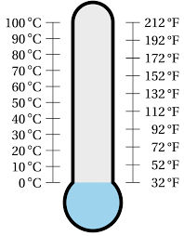
____________ ____________ ___________ ___________

Explain observations and results:
____________________________________________________________________________________________________________________________________________________________________________________________________________________________________________________________________________________________________________________________________________________________________________________________________________________________________________________________________________________________________________________________________________________________________________________________________________

Conclusion:
____________________________________________________________________________________________________________________________________________________________________________________________________________________________________________________________________________________________________________________________________________________________________________________________________________________________________________________________________________________________________________________________________________________________________________________________________________

