Using Changes
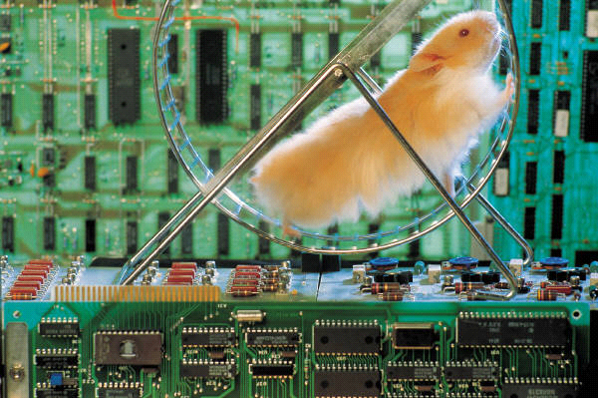
- Define:
Raw materials:_______________________________________________________________________
what are two examples of raw materials:___________________________________________
Manufactures materials: _______________________________________________________________
what are two examples of manufactured materials:________________________________________
2.What new materials have been developed in your lifetime? In your parents?
____________________________________________________________________________________
____________________________________________________________________________________
3.What do you think would happen if companies stopped developing new materials and products?
____________________________________________________________________________________
____________________________________________________________________________________
4.Give an example of a raw material and a manufactured material you use every day.

5.An alloy is a manufactured from raw materials. Choose one of the following alloys to research:
*brass *sterling silver
*stainless steel *bronze
Answer each of the following questions:
- What is this alloy used for? When was it first used?

- What materials make up this alloy?

- What are the properties of the materials that make up the alloy?

- Describe the properties of the alloy itself?

- How are the properties of the materials that make up the alloy different from the properties of the alloy itself?

