Seeds, Roots & Stems experiments
In a sentence, write a prediction of what you think will happen. Then write your observations in full sentences of the result and whether your prediction was true or not. Draw a coloured illustration.
Seeds: How will the potato plant show the growth of seeds?

I predict: _______________________________________
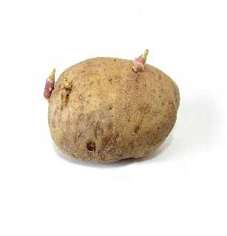
_______________________________________________
_______________________________________________
I observed _______________________________________
_________________________________________________
_________________________________________________
_________________________________________________

Stems: How will the food colouring show how stems work?
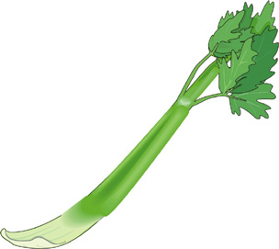
I predict: _______________________________________
_______________________________________________
_______________________________________________
I observed _______________________________________
_________________________________________________
_________________________________________________
_________________________________________________

Roots: How will the beet root act in dark and moist areas?
I predict: _______________________________________
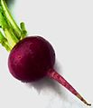
______________________________________________
_______________________________________________
I observed _______________________________________
_________________________________________________
_________________________________________________
_________________________________________________

