Lab# Observing the Purpose and Properties of
Saskatchewan’s Rocks & Minerals
Name & Partners: Date:

Purpose: To observe, compare and describe the properties of each rock or mineral sample (sodium or salt, potash, and coal) with the naked eye observation to predict how we use these resources in Saskatchewan and Canada.

Hypothesis: I predict that these rock/mineral may be used for: coal_________________________ .
potash: ________________ and salt/sodium: _______________

Materials:
-3 rocks and minerals: -pencil
-salt (sodium) -magnifying glass
-potash -colouring tools
-coal -resources text or computers

Procedures:
- Observe the surface of each mineral with a naked eye inspection.
- Have chart prepared and label what each sample is in all three columns.
- Describe in sentences the appearance of each of the samples. Observe the shape, colour, texture, crystal shape and size, texture and dullness or shininess of each sample material.
- Draw and colour this rock/mineral on your chart, look closely at any special these features and illustrate in detail your observations
- Predict from the appearance of your mineral sample several uses it may serve and explain your reasons.
- Refer back to your hypothesis and in your conclusion restate whether your prediction was correct
Observations: Fill out the table
Salt or  Sodium | Potash | Coal
draw : | draw : | draw :
describe its appearance & features: | describe its appearance & | describe its appearance & features:
Guess which classification of rock  -igneous  -sedimentary  -metamorphic  Research: which is it? | Guess which classification of rock  -igneous  -sedimentary  -metamorphic  Research: which is it? | Guess which classification of rock  -igneous  -sedimentary  -metamorphic  Research: which is it?
Predict: how or why do people use this resource? | Predict: how or why do people use this resource? | Predict: how or why do people use this resource?
Research: what is it used for?  Where is it mined in Saskatchewan? | Research: what is it used for?  Where is it mined in Saskatchewan? | Research: what is it used for?  Where is it mined in Saskatchewan?
Where can you find this in Canada? | Where can you find this in Canada? | Where can you find this in Canada?

Conclusion:

____________________________________________________________________________________________________________________________________________________________________________________________________________________________________________________________________________________________________________

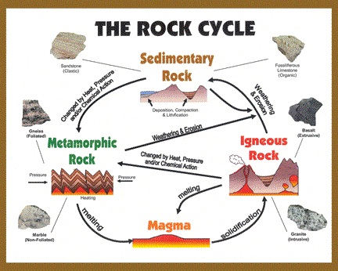
This Photo by Unknown Author is licensed under CC BY-SA

