Properties of Matter
Matter is anything that takes up space and has mass. Mass of matter is the amount of matter of an object. A scale is used to measure mass. Volume is the measurement of the amount of space an object takes up. To measure Volume of a regular shaped solid we measure its length x width x height.
V= L x W x H
Volume & Properties | Object
Length:  width:  Height:  Volume= _____ x____x_____  _______  Describe the properties:  - -  - -  - - | 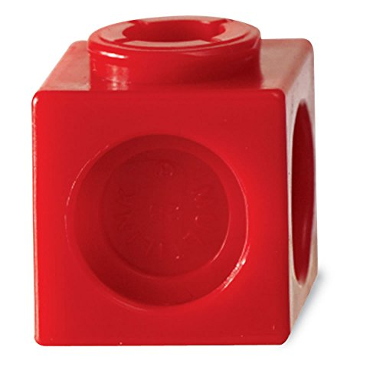
Length:

width:

Height:

Volume= _____ x____x_____
_______
Describe the properties:
- -
- -
- -

Length:

width:

Height:

Volume= _____ x____x_____
_______
Describe the properties:
- -
- -
- -

Properties of Matter

actual mass: _________
Cube link | property | description
 | mass | the amount of matter in an object
 | volume | the amount of space an object takes up
 | colour | the colour of the object
 | texture | what an object feels like when you touch it
 | hardness | the ability of an object to be scratched
 | flexibility | How much an object can bend before it breaks
 | absorbency | whether an object can soak up liquids
 | strength | how strong or weak an object is
 | buoyancy | whether or not an object floats
Now that you know the mass of 1 cube link. Make a sculpture, draw then predict mass. Repeat for #2.
My structure has _____ blocks. I predict it will weigh _______  MY STRUCTURE #1  actual mass: _________ | My structure has _____ blocks. I predict it will weigh _______  MY STRUCTURE #2  actual mass: _________
Observations:
____________________________________________________________________________________________________________________________________________________________________________________________________________________________________________________________________________________________________________________________________________________

