Weather Lab # Properties of Air
Name and partners: date:
Purpose: to test the theory that warm and cold air masses have different effects on the weather because warm air rises and cool air sinks.
Hypothesis: I predict that the bottle in hot water will ___________ the balloon and the bottle in the cold water will ____________ the balloon.
Materials:
-2 medium sized bowls -hot water
-ice water -balloon
-plastic 2 L bottle

Procedure:
- Fill one bowl half way with hot water and the other bowl halfway with ice water (safety caution: do not splash hot water on yourself or on anyone near you).
- Stretch a balloon over the opening of the bottle.
- Predict what will happen when you stand the bottle in the bowl of hot water. Then, stand the bottle in the hot water to test your prediction.
- Predict what will happen if you move the bottle to the bowl of ice water. Then, stand the bottle in the ice water to test your prediction.
- Record your observations, draw an illustration of what happened with a caption explaining the results. Be sure to include a drawing of before and after being placed in each bowl of water.
- Answer the questions in complete sentences, explaining your understanding on Communicate.
- Write a conclusion of whether your prediction was correct or not and why.

Conclusion: My prediction was

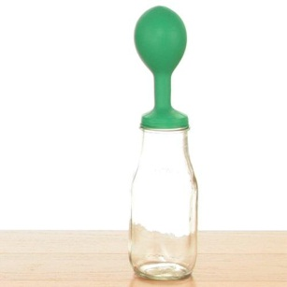
Communicate
- What happened to the air inside the bottle once the bottle was places in each bowl?
Ice water bowl:
Hot water bowl:

- Explain what you think would happen if you put the bottle in the cold water first, and then in the hot water.
_________________________________________________________________________________________________________________________________________________________________________________________________________________________________________________________________________________________________________________

- What would you say to someone who thinks an inflated balloon is empty? Explain your answer using the properties of air.
___________________________________________________________________________________________________________________________________________________________________________________________________________________________________________________

- Think about how warm and cold air move. Where in a two-storey home would you expect to find the colder rooms? Explain your answer and include a drawing to show how air moves indoors.
____________________________________________________________________________________________________________________________________________________________________________________________________________________________________________________

