Pow Wow Inquiry outline:
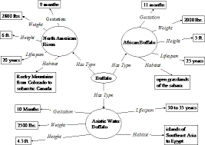
Pre-writing:
1. Graphic organizer
-have a graphic organizer outlining the topics, put in bullet form
2. Outline: prepare for jot notes
-fold loose leaf in half, have a title for jot notes
-put a title for each category on a half-page
-write questions for research
-when researching, write the link or name of website for reference
-scan for important details, read important information, put in you own words and write jot notes
(do for each topic, compile all your data, 3 points or sentences for each topic)
3. Open a Word Document
-go to the W icon and press file, go to “new” word document
-go to file again and click on “Save as”, you may have to right click more than once
-it will prompt where to save, you hit PC until it gives you options: find your name
-when you find your name, click on it, that is
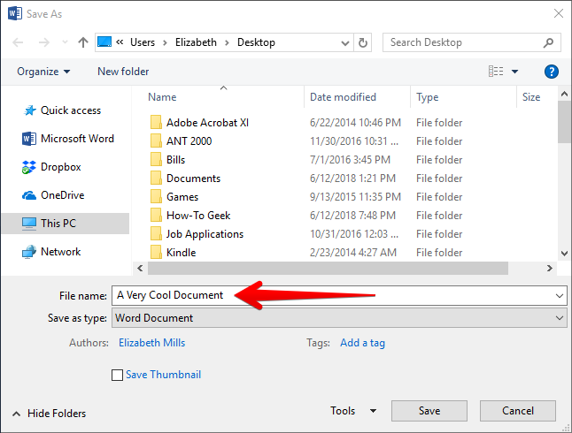
where you will save
-you need to type in the name of the file,
“Pow Wow Pictures” or “Grass Dance Pictures”
Then press save. You can minimize the
document when you go to search.
-you can hit the save button at the top every
time you add pictures or text,
it will save to your m drive or USB

4. Browsing internet: Google
-Ask a specific question in Google “What is the regalia worn in Women’s traditional pow wow dance?”23 (for kids)
-you can hit “all” and you will have documents, websites, etc. If you just want to watch videos you hit videos, or images for pictures. Write down the website name so you may come back to it.
-most of the content will be adult oriented, so being able to scan for headings, captions, pictures are important, make jot notes along the way
-if a site is too difficult press the arrow button at the top to go back to the search page, try many websites or videos until you find one that works for you
5. Saving pictures:
-when you right click on a picture a bar will come up, you press “COPY” then minimize and go to your word document and press “Paste”, you must have a word document open to save it to
-many pictures have strict copyright, and you may not be able to copy and paste
-be sure to write a caption or refer to where you got the picture so you may go back
-press the save button on top every time you add a picture, not all computers autosave
-to copy pictures, you can adjust size and location on the page: right click on
the corner, if wanting to resize you can drag to make larger or smaller
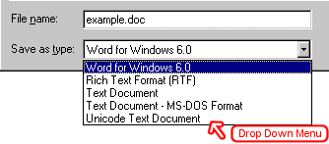
-another icon will prompt to move it either through cursor or dragging
6. Saving Document
-file-right click-save as-to m drive-name document then press save
7. Visual Presentation:
After you have all your data collected and pictures you will choose
how to present your pow wow dance visually. If you are wanting to print copied pictures from school-they are in black and white, therefore will need to be coloured neatly.
-power point -poster -pamphlet -booklet
*If you are teaming up with a partner or group, everyone must take on equal work and be using class time to do work (example: one person does power point while the other just sits and watches-no!)
8. Self-Assessment: checklist
-fill out the checklist to check you have everything
-give yourself a mark out of ten and explain why/support it with details

