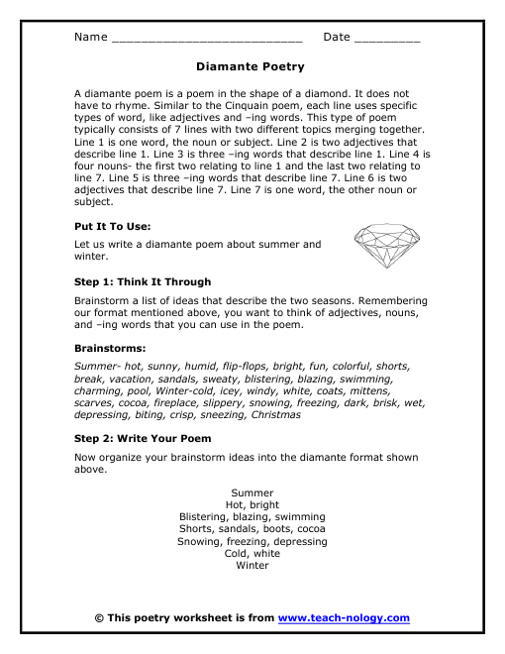

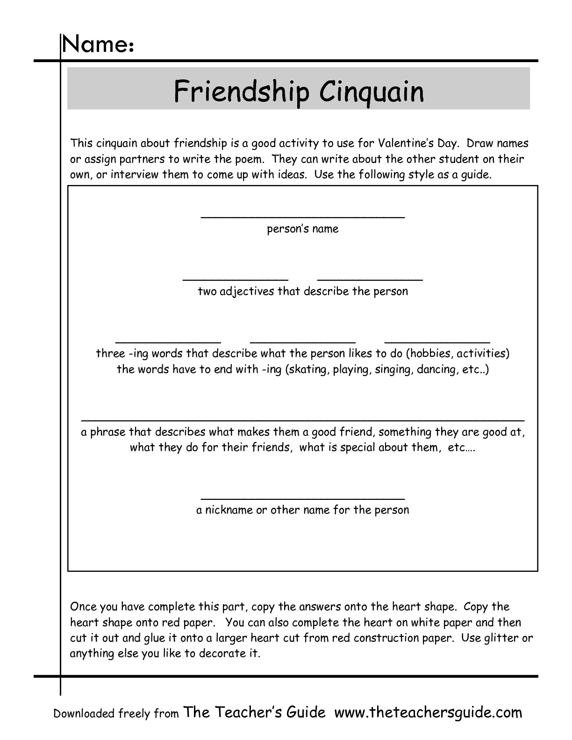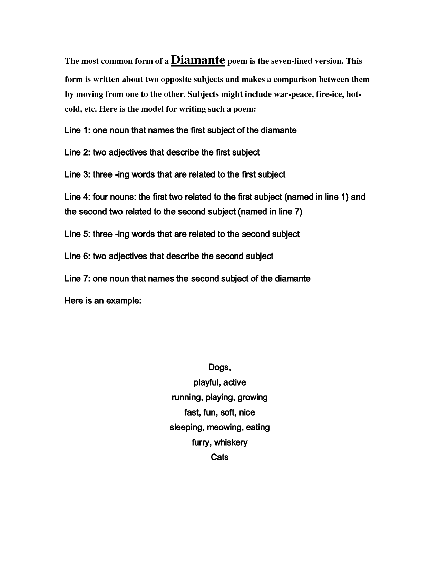

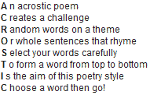

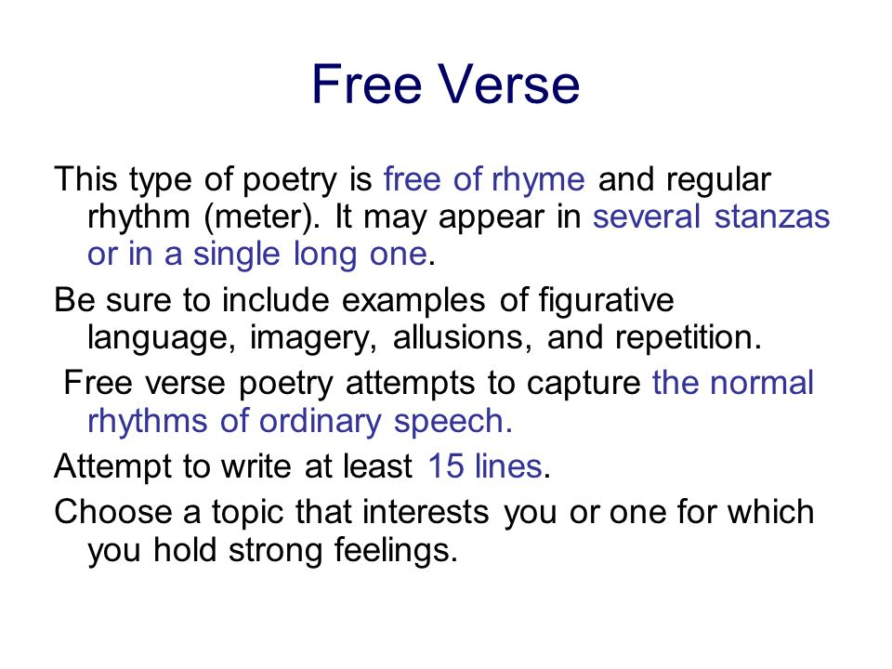

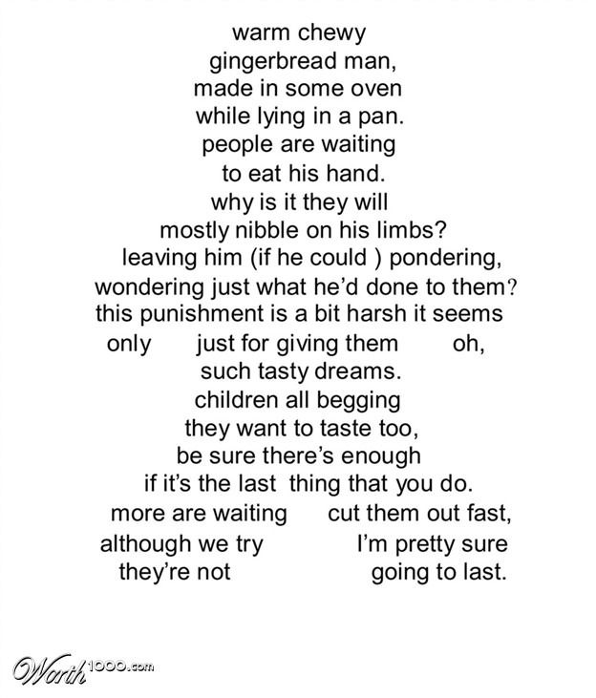

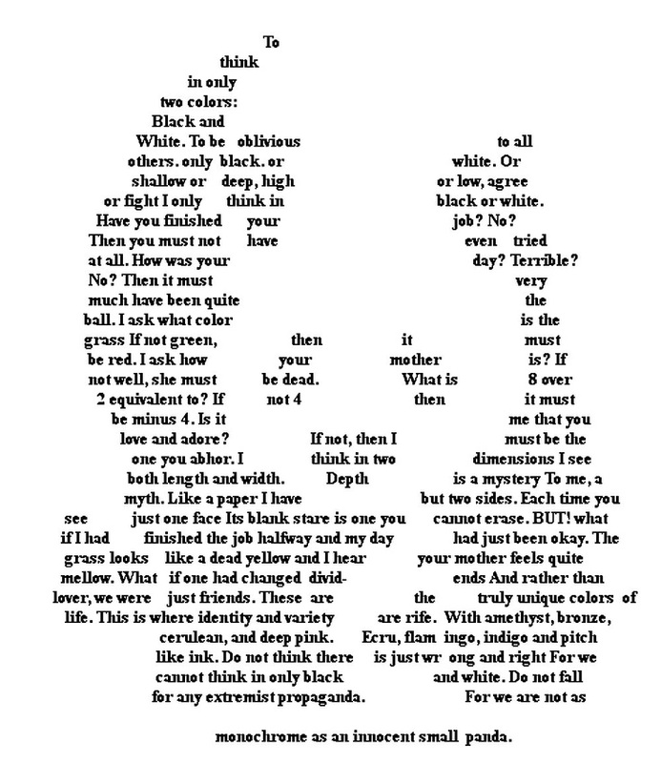

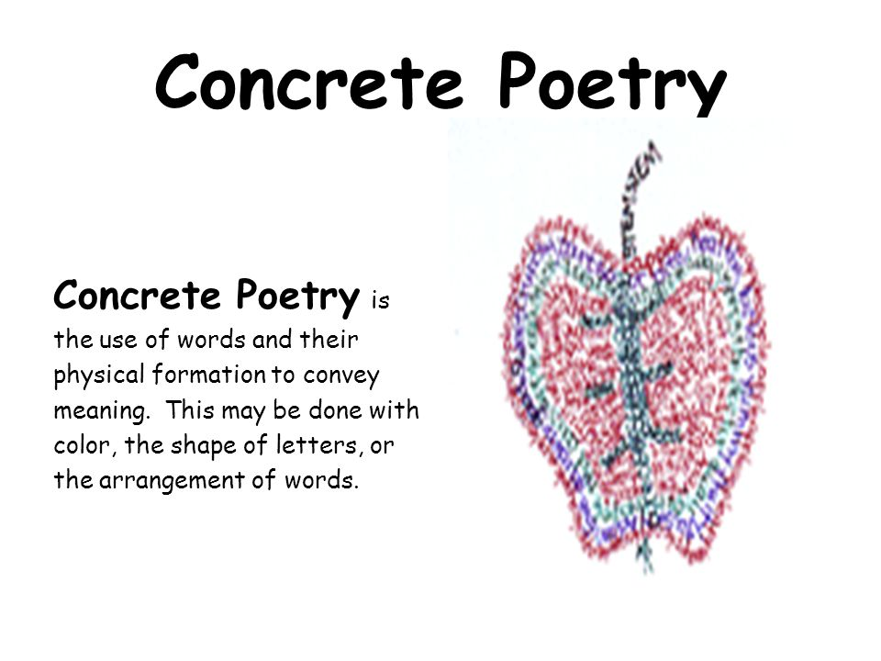

**What is a Shape Poem?**

A Shape Poem is a type of poetry that describes an object and is shaped the same as the object the poem is describing.

You could write your shape poem on anything.

**What Shapes Could You Make Your Poetry?**

You could have a circle-shaped poem describing a cookie, or a poem about love shaped like a heart.

**An Example of a Shape Poem**

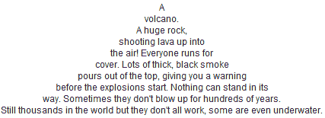

Reading

**Lyric poems**

**Free Verse**

**Haiku**

**Acrostic**

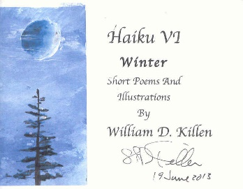 & 

**Diamante**

**Rhyming Couplets**

Writing

**Quatrain**

**Concrete/ Shape**

**Cinquain**

Poetry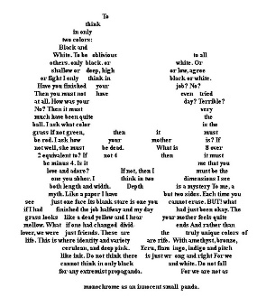

**Narrative Poems**

**Irony**

**Personification**

**Metaphors**

**Onomatopeia**

**Hyperbole**

**Alliteration**

**Literary devices**

**Similes**