North West Resistance 1885 Inquiry
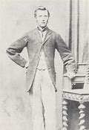
Thomas Scott

The execution Of Thomas Scott March 4, 1870
Explain what the push/pull factors that led to Thomas Scott being executed and
the result after the fact. How did this event assist in leading the Resistance
movement of 1885?
__________________________________________________________________________________________________________________________________________________________________________________________________________________________________________________________________________________________________________________________________________________________________________________________________________________
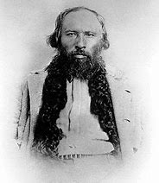
Gabriel Dumont

The Battle at Duck Lake March 26,^{th} 1885
Explain what happened at the Battle of Duck Lake, who the participants were
and what the result was.
_________________________________________________________________________________________________________________________________________________________________________________________________________________________________________________________________________________________________________________________________________________________________________________________________________________
_________________________________________________________________________________________________________________________________________________________________________________________________________________________________________________________________________________________________________________________________________________________________________________________________________________
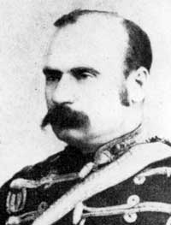
Leif Crozier, Fort Carlton Police Super Intendent

North West Resistance 1885 Inquiry continued…
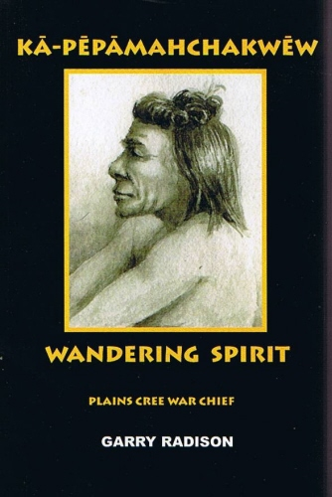
The Frog Lake Massacre April 2, 1885
Chief Big Bear
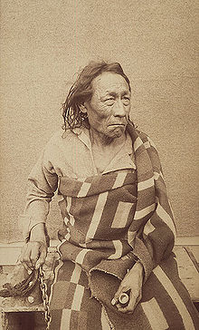
Big Bear was the chief of Pound Cree Nation (near North
Battleford). His war chief, Wandering Spirit led attacks on Frog
Laker and captured Fort Pitt, without Big Bear’s approval.
What happened at the Frog Lake Massacre? What in turn happened
at Fort Pitt two weeks later? Why do you think Wandering Spirit used
militant tactics?
__________________________________________________________________________________________________________________________________________________________________________________________________________________________________________________________________________________________________________________________________________________________________________________________________________________ ____________________________________________________________________________________________________________________________________________________________________________________________________________________________________________________________________________
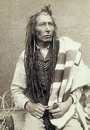
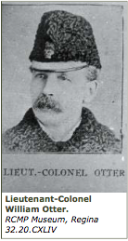
The Battle at Cut Knife Hill May 2nd, 1885
Summarize the battle between Colonel William Otter and his militia
with Cree Chief Poundmaker’s warriors (Cree war chief Fineday).
__________________________________________________________________________________________________________________________________________________________________________________________________________________________________________________________________________________________________________________________________________________________________________________________________________________ __________________________________________________________________________________________________________________________________________________________________________________________________________________________________________________________________________________________________________________________________________________________________________________________________________________
Chief Poundmaker
https://teaching.usask.ca/indigenoussk/import/cut_knife_hill_battle_of.php

