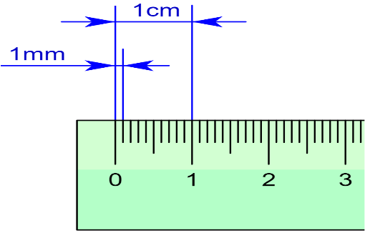 Measuring Mealworms
This Photo by Unknown Author is licensed under CC BY-SA
Tips: the larva are “squishy” or easy to hurt. A good way to gather information your mealworm is to gently handle them:
- Empty the container gently on an empty desk top
- Route through the oats looking for movement, molted skin, etc
- Use a flat piece of paper to gently slide under your larva
- Place larva in the middle of your desk
- Use a string to lay out alongside your mealworm and mark with a pen or marker to the end of the mealworm

- Using a ruler, lay out the string at zero to measure the length of the mealworm larva

- Repeat for each mealworm, use a paper to slide underneath to return them to their habitat

*remember-be gentle and respectful, these are living things

