Name: Date:

Chapter 8 Test Page 1
1. Write these times using numbers and a.m. or p.m.

a) 1 o’clock in the morning b) 11 o’clock at night

- Write these morning times 2 ways with numbers and words.

3. Write the numeric date and the 24-hour time for your birth.

- Write the numeric date and the 24-hour time of your first class of the day (today).

5. Write the 24 hour time in standard form.

22:45

6. Write the 24-hour time in standard form.
09:56
______________________________________________

7. Write the standard time in the 24-hour time form.
7:30 AM

__________________________________________
8. Write the standard time in the 240-hour form.
9:45 PM

9. Write the times using numbers and A.M. or P.M.

- A quarter to 10 in the morning.

- A quarter past 11 at night.

10. Write the numeric date in calendar form.
2000-10-30

11. Write the calendar date using numeric form. _____
September 13, 2006

12. Write the following times on the clock faces.

- A quarter past 7. b) half-past 2.

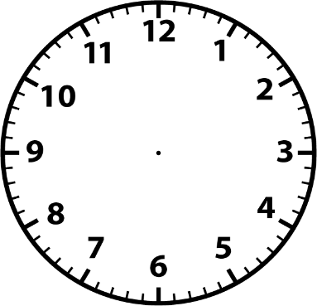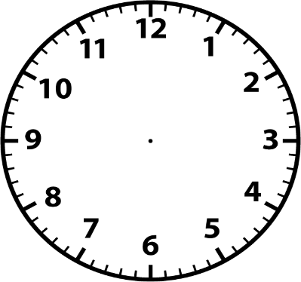

c). 25 minutes to 9. d). 7 minutes before 4.
