Lab Report Rubric outline
Report Skills | Thorough understanding  4 | Good  Understanding  3 | Is beginning to show understanding  2 | Needs more  Work  1
Lab Structure | Has all components in detail:  Purpose, hypothesis, materials , procedure, observations and conclusion | Most lab components done or have some detail: Purpose, hypothesis, materials, procedure, observations & conclusion | Some parts of the lab are completed or done partially: Purpose, hypothesis, materials, procedure, observations & conclusion | Many or all parts of the lab are incomplete: Purpose, hypothesis, materials, procedure, observations & conclusion
Organization  Diagrams/ Data | The number of lab & appropriate related title, date, student name and partners in group  -All diagrams, charts, illustrations are neatly organized to provide data  (if applicable) | Most key information is there: the number of lab & appropriate related title, date, student name and partners in group  -Diagrams, charts, or graphs are neatly illustrated | Parts of lab are missing: The number of lab & appropriate related title, date, student name and partners in group  -diagrams or charts are partially done | No name, no number, partners in the lab group or date was written  -no illustration, data, charts or graphs
Neatness & appearance | The lab is easy to read, legible printing and pride was taken in the appearance of work | Lab is readable and printed legibly | Printing is hard to understand, words are spaced too close together, there may be unnecessary doodles or rips | Lab report paper is ripped, coloured on, crumpled and impossible to decipher any written print
Spelling, Punctuation & Grammar | Lab report was edited for all errors in spelling, grammar, and has clear logical explanations | There are just 1-2 errors in spelling, grammar, or meaning in the lab | There are 3-4 errors that need to be edited | Lab is flawed with numerous errors in spelling, punctuation or makes no sense at all when read
Experimental Design:  Conclusion | Conclusion relates back to the hypothesis and denies or confirms if it was correct.  Lab ends with a summary of evidence of observations taken in the conclusion | Conclusion gives some answer to whether prediction was correct or not. Lab is appropriately ended with a sentence explaining results or restating observations. | Conclusion is partially done. It either states just that the prediction was correct or just writes an ending in a sentence what happened. | Conclusion is left blank altogether or has absolutely nothing to do with what is being tested.
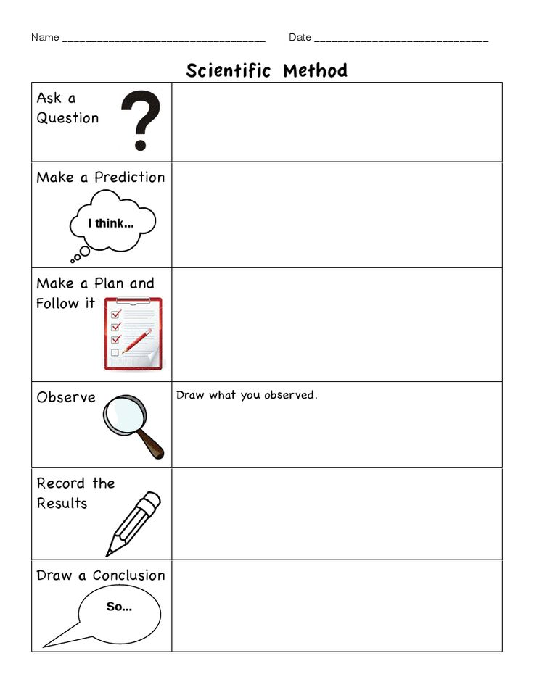
Conclusion: end the lab by restating your prediction, confirming whether your original was correct (hypothesis) or incorrect and support why. Briefly end report by summarizing what happened to confirm or negate theory.
Organize data using pictures, charts, graphs and captions explaining the process and observations.
Observations: write down what you observed, details of what happened and explain results in complete sentences.
Materials: in point form outline and organize what items you will need to perform the experiment.

Procedure: write down each step in order of what you are to do (number each step in sequence) to perform the experiment. This is important so you may get the same results if you perform the same test again.
Hypothesis: before you perform or test theories predict what you think will happen or what the end result will be.
Purpose: What theory are you testing, why are you doing this experiment (a reason)? Ask a question or outline the concept you are exploring.

