Lab # Wind Socks Name & Partners Date:
Purpose: the create a weather tool, a wind sock, to communicate which compass direction the wind is blowing and predict the velocity of wind movement
Hypothesis: I predict that the wind sock tails will blow in the direction _______________ since the wind is blowing from ______________.

Materials:
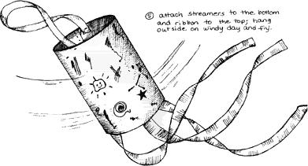
-scissors -9 by 14 oak tag paper
-glue/tape/stapler -streamers of varying lengths
-pencil crayons -hole punch
-string

Procedure:
1. decorate 9 by 14 oak tag paper with different colours and symbols
2. roll the oak tak into a tube either in the shape of a cyclinder or a funnel shape (large at the top and smaller at the bottom)
3. glue on streamers at the bottom of the wind sock
4. punch two holes (opposite sides for balance) an inch from the top
5.thread a string through the two holes creating a handle
6. hang your wind sock on a tree and observe which direction the wind blows (north-east-south-west)
7. observe how fast or slow the streamers move: is the wind velocity a light breeze, non existant, or heavy wind
8. draw a picture of your wind sock blowing in the wind (use the whole space) on the back of this page, write a caption of direction and wind velocity
9. document your observations and complete your conclusion
Observations: Illustrate your wind sock placement, show the air mass and diresction of wind sock, use a compass rose. Explain your observations.
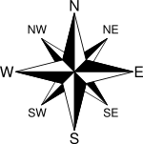

____________________________________________________________________________________________________________________________________________________________________________________________________________________________________________________________________________________________________________________________________________________________________________________________________________________________________________________________________________________
Conclusion:

