Personal journal writing Outline for September

- must have title and date
-have an topic sentence introducing the idea
-have a minimum of three paragraphs of writing, (5-10 sentences in length)
-sentences that support the topic and provides more detail
-have neat printing
-be single spaced
-be well organized, indented and writing to the margin
-have a half page illustration to support the topic
-expresses ideas, thoughts, feelings and opinions
-underline unknown spelling or circle for better word choice
-re-read when finished and correct errors, edit for better word choices or change so your writing can make sense
-self assess using a rubric

Rough Draft Writing
Outline

-must have title and date
-use a semantic map or graphic organizer or thematic web to outline key ideas
-notes made in own words (jot notes for expository text)
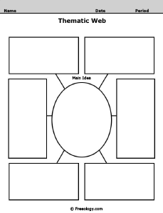
-have a topic sentence introducing the main idea for each paragraph
-have a minimum of three paragraphs of writing, (5-10 sentences in length)
-sentences that support the topic and provides more details

Habitat
Topic
Animals

-have neat printing (finger spaces between words)
-be double spaced (space for peers and teacher to edit)
-be well organized, indented and writing to the margin
-have 5 or more supporting details
-sentences start differently and have describing words
-has both simple and complex sentence structures
-underline unknown spelling or circle for better word choice
-re-read when finished, correct errors, edit writing for richer vocabulary or change so writing can make sense

