Independent Book Project Outline
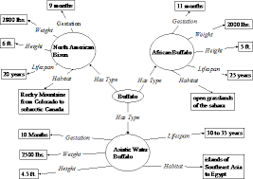
Pre-writing:
1. Graphic organizer
-have a graphic organizer outlining the topics, put in bullet form in
Your green rough draft notebook
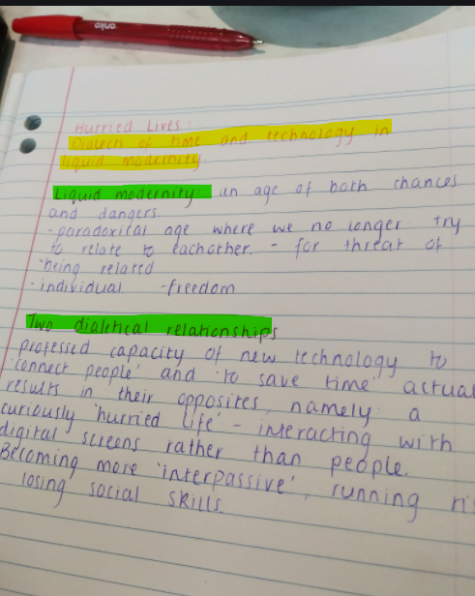
2. Outline: title and jot notes
-in your rough draft notebook make an outline (jot notes)
-introduction persuasive writing paragraph: introducing book
and 3 reasons why it is a good book
-setting details, characters and your favourite part
-a summary paragraph of the important highlight:
beginning, middle and end without “spoilers”
-a paragraph on vocabulary and audience (5 finger rule and IPICK strategy)
-conclusion: restate why this is a good book, and summarize key details to close

3. Rough Draft Writing:
-start writing a rough draft of your outline (use reading log entries), make sure to
double space, underline unknown spelling, and circle for better word choices

4. Re-read and self-edit:
-look over and read your rough draft to make improvements
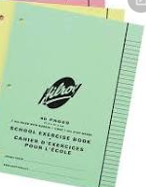
by revising wording of sentences and editing for errors
-look up word spelling in the dictionary and use thesaurus for better word choices
-fix all punctuation, capitalization, and grammatical errors
-have a friend, parent, or teacher edit (make suggestions)
-if needed, make a new improved draft (optional)
5. Open a Word Document: Typing Good Copy
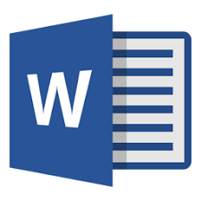
-go to the W icon and press file, go to “new” word document
-go to file again and click on “Save as”, you may have to right click more than once
-it will prompt where to save, you hit PC until it gives you options: find your name
-when you find your name, click on it, that is
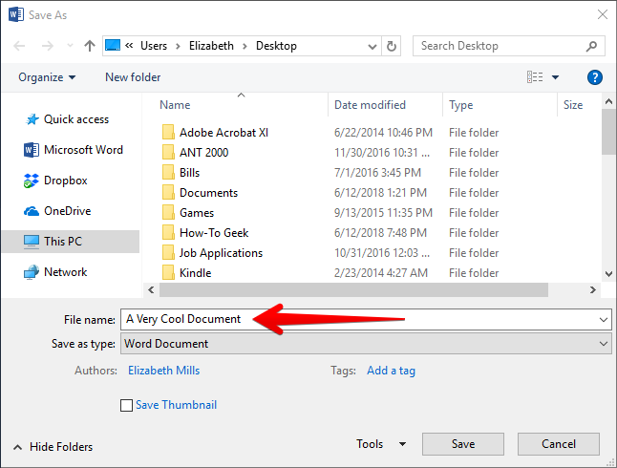
where you will save
-you need to type in the name of the file,
“Book Report on ___________”
Then press save. You can minimize the
document when you go to search.
-you can hit the save button at the top every
time you add or change text,
it will save to your m drive or USB

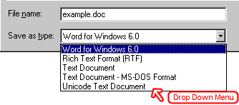
6. Saving Document
-file-right click-save as-to m drive (or USB)
-name document then press save
-when you return to saved work, you go
To “file” and press “OPEN”

7. Browsing internet: Google
-if you are looking for an image of the cover of your book, or pictures to support writing you can
a) go to Google
b) go to the task bar and type in a specific question or request “cover of the book Number the Stars”
-you can hit “all” and you will have documents, websites, etc. or you can click on “images” or “videos”
Write down the website name so you may come back to it later
-most of the content on the internet will be adult oriented, so being able to scan for headings, captions, pictures are important, make jot notes along the way
-if a site is too difficult press the arrow button at the top to go back to the search page and add “for kids”

6. Saving pictures: Open New Word Document
-when you right click on a picture a bar will come up, you press “COPY” then minimize and go to your word document and press “Paste”, you must have a word document open to save it to
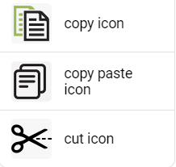
-many pictures have strict copyright, and you may not be able to copy and paste
-be sure to write a caption or refer to where you got the picture so you may go back
-press the save button on top every time you add a picture, not all computers autosave
-to copy pictures, you can adjust size and location on the page: right click on
the corner, if wanting to resize you can drag to make larger or smaller
-another icon will prompt to move it either through cursor or dragging
You might need to go to top of page and choose a text box then save or
Copy picture there (easy to resize) or use the “snip and sketch” option
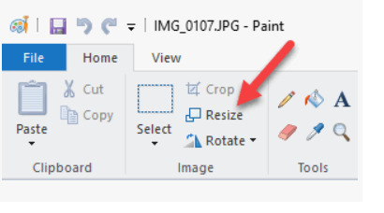

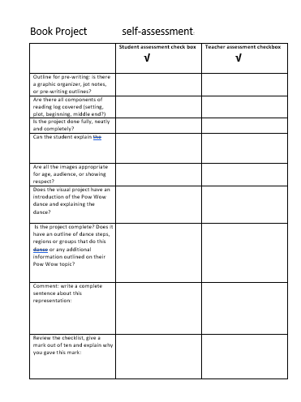
7. Self-Assessment: checklist
-fill out the checklist to check you have everything
-give yourself a mark out of ten and explain why/support it with details

