Lab # Energy from the Sun: Rate of Melting
Date: Name & Partners:
Purpose: To test to see if the sun’s energy heats up and melts ice cubes at the same rate
Hypothesis: I predict that the ice cube will melt the fastest on the________________ surface and the slowest on the ______________ surface.
Materials:
-5 ice cubes -1 cup - 4 surfaces: wood, concrete, asphalt & grass
-lab report -stop watches -pencil
Procedure:
- time how long it takes using a stop watch for an ice cube to melt at room temperature (20-23◦C).
- Observe the properties of each surface and predict which will absorb the sun’s heat energy the most.
- Answer communication questions to help support your hypothesis.
- Write your predictions of what surfaces the ice cube will melt rapidly.
- Place an ice cube on each surface: grass, wood, asphalt and concrete and time each sample using a stop watch
- Wait and record the observations and time for each.
- Refer back to your hypothesis, refute or confirm if it was correct and explain why.

Communication:
On a hot summer day, where would you prefer to sit in the afternoon: on the grass, in a sandbox, on a concrete sidewalk, on a wood deck or an asphalt basketball court? Explain your choice. Which location do you think would be the worst and why? Draw a picture of each.

Explain why the average temperature in a desert (near the equator) would be higher than the average temperature on a mountain in Canada?
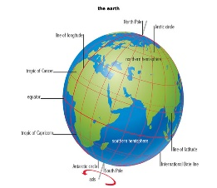
This Photo by Unknown Author is licensed under CC BY-ND
Observations:
Chart your observations on a table:

Surface | Rate of Melting in minutes and seconds
room temperature
grass
concrete
asphalt
wood

Explain: which surface had the most rapid rate of melting the ice cube:
wood grass asphalt concrete
________________________________________________________________________________________________________________________________________________________________________________________
________________________________________________________________________________________________________________________________________________________________________________________
________________________________________________________________________________________________________________________________________________________________________________________
________________________________________________________________________________________________________________________________________________________________________________________

Conclusion:

