Energy from the Sun: Rate of Melting
Document the temperature on each of these samples.
sand soil water
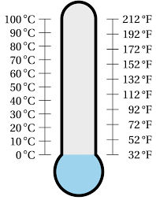
Observations: ________________________________________________________________________________________________________________________________________________________________________________________________________________________________________________________________________________________________________________________
Observations: which surface had the most rapid rate of melting the ice cube:

wood grass asphalt concrete
________________________________________________________________________________________________________________________________________________________________________________________
________________________________________________________________________________________________________________________________________________________________________________________
________________________________________________________________________________________________________________________________________________________________________________________
________________________________________________________________________________________________________________________________________________________________________________________

