December 2, 2019

Grade 4 Classroom Newsletter



Dear parents,

It is hard to believe that it is December already and soon we will be saying farewell for the December break. I would like to thank you for your support and feedback at three-way conferences. It was an excellent experience seeing all our students and their families. As a staff, we value these times that we can connect with our families. Three-way conferences are a great time to show case your child’s talents.

Thank you for all the communication of emails, day planner notes and phone calls. Thank you for letting the school know when you are away on holidays or if your child is sick. During the school day, sometimes I get emails throughout the day about a different dismissal procedures or reminders for students. Because I check my email only once or twice a day, time sensitive messages may not get to your child. I would like to request a faster method that guarantees I can attend to your message. If you can contact the school and ask to leave a message on my voicemail, I can get the message more promptly.

I just wanted families to know that I will be away from December 11th to December 19th. I will return on December 20th before the winter break. Ms. Emily Fillo will be with the class for that duration of time. Her contact email is [filloe@spsd.sk.ca](mailto:filloe@spsd.sk.ca). The class blog will not be updated daily during this time, but students will still have daily communication with their agenda. With several students absent for December, I have scheduled the math test for the last Thursday before the break. Those who are away will take it (after some review) in January when we return. The option for re-testing will be on the same date if students are wanting to improve their mark.

I would like to thank you for signing your child’s day planner each day. I appreciate this extra effort, especially in this busy season where there is so many events taking place. Organization and communication support good working habits, awareness of important school and classroom events, and assists each child in their independence to take responsibility for their learning. I would also like to thank you for continued support of ensuring that your child has adequate clothing for the cold winter weather. It is an expectation that all students go outside for fresh air and physical activity. Students will be invited to participate in indoor recess activities or lunch when the temperature is -27 degrees Celsius.

**Dates for December**

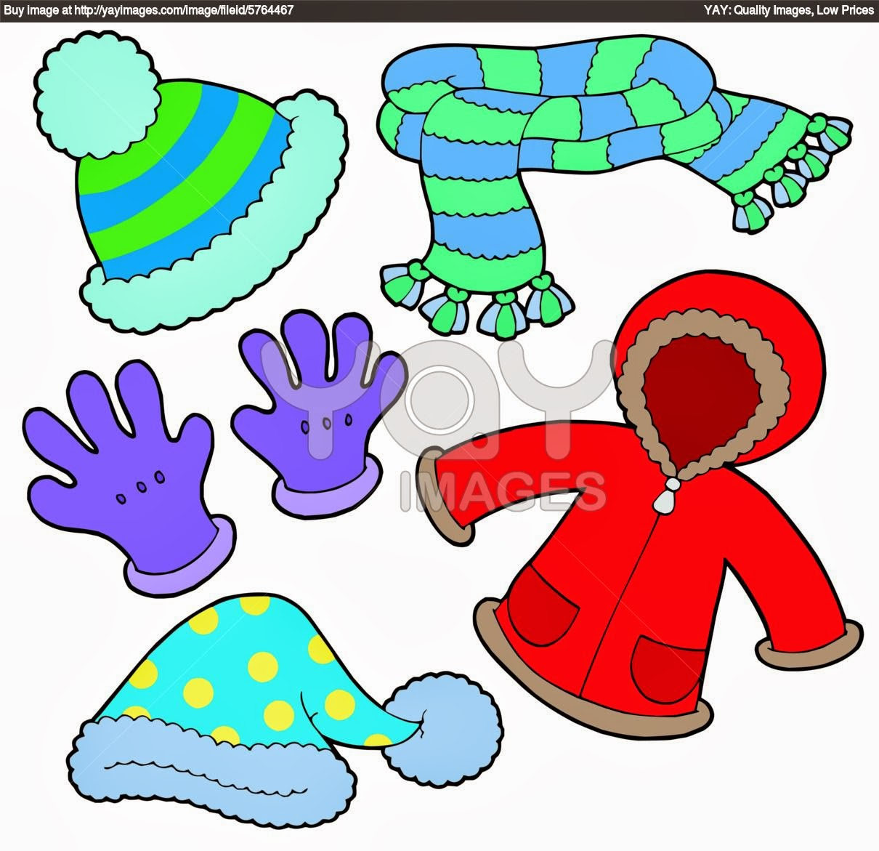

Tuesday, December 4 -assembly/band concert

 Friday, December 6 -Bake/Treasure Sale

Thursday, December 19 -Place Value math test

Friday, December 20 -last day until break

Pm class party (games)

Dec. 21-January 6 -winter break

Monday, January 7 -first day back for students

[](http://www.google.ca/url?sa=i&source=images&cd=&cad=rja&docid=i3K934hyv5sARM&tbnid=yYJgm7632WDPzM:&ved=0CAgQjRw&url=http://www.math-360.com/imo_site/product/curriculum-standards/&ei=ebLIUsXCBqer2QWcuoGACw&psig=AFQjCNFvF4Ae-iqtFm7DKroLfvOKUezYxw&ust=1388971001142857)

**Learning outcomes for December**   
**Language Arts:**

-dictionary and thesaurus skills: using reference materials to locate definitions, synonyms and antonyms

-using context clues, chunking, re-reading and knowledge to identify unknown vocabulary

-developing vocabulary: explicit instruction and activities; word sorts, letters sorts

-reading logs: monitoring and clarifying instruction, activities and reading logs

-writing: purpose writing card prompts: to entertain, to inform or persuade

-creating graphic organizers to brainstorm and plan for pre-writing

-rough drafts writing (multiple paragraphs), topic sentences, expanding on details and revising for richer vocabulary word choices

*assessments: daily work completed thoroughly and corrected, weekly writing drafts, reading log entries

**Math: Place Value**

-rounding numbers, comparing numbers using place value (greater than and lesser than) and expressing place value by looking at number form, word form, and expanded form

-exploring numbers to the ten thousand places with models, place value charts, and base ten blocks

*assessments: daily work completed thoroughly and corrected, math journal textbook work, hands on group activities, and summative end of unit test

**Science**: **Sound introduction**

- explain how sounds are used for various purposes such as enjoyment, warning, navigation, annoyance, ambience, and communication

-identify and classify, using student-developed criteria, examples of natural and artificial sounds in their environments (e.g., classroom, school, home, playground, and community

-differentiate among the types of sounds produced by various stringed, woodwind, brass, and percussion instruments

*assessments: daily work completed thoroughly and corrected, scientific process of documenting, organizing data in lab reports, and summative open book quiz

**Social Studies**: **Dynamic Relationships**: introduction

-geographical features, political boundaries, and symbols of Saskatchewan and Canada

-exploring First Nations traditional boundaries in Saskatchewan

*assessments: daily work completed thoroughly and corrected, data collection with graphs, tables, charts and inquiry projects, and mapping assignments neatly completed, open book quiz

**Health**: **Wellness**: introduction:

-what is stress and management techniques

-wellness wheel, medicine wheel, and balance of 4 domains of wellness: spiritual, physical, mental, and emotional

*assessment: group and partner work, class assignments and projects

**Dance:** ongoing and closure

**Pow Wow inquiry unit**

-researching using a web organizer: regalia, steps of dance, significance, and other important information (Grass, Jingle, Traditional etc) and presenting a visual presentation (assessed by checklist)

-Just Dance participation in daily body breaks



If you need to contact me, please email me at [cumingc@spsd.sk.ca](mailto:cumingc@spsd.sk.ca)

Check out the blog at <http://www.cuming-klassenclassroom.com/>

Best regards,

Coralee Cuming

|  |
| --- |
|  |
|  |  |
|  |  |
|  |  |
|  |  |
|  |  |
|  |  |