Grade 4/5 Class Newsletter

December 4, 2018



Dear parents,

It is hard to believe that it is December already and soon we will be saying farewell for the December break. I would like to thank you for your support and feedback at three-way conferences. It was an excellent experience seeing all our students and their families. As a staff, we value these times that we can connect with our families. Three-way conferences are a great time to show case your child’s talents.

Thank you for all the communication of emails, day planner notes and phone calls. Thank you for letting the school know when you are away on holidays or if your child is sick. During the school day, sometimes I get emails throughout the day about a different dismissal procedures or reminders for students. Because I check my email only once or twice a day, time sensitive messages may not get to your child. I would like to request a faster method that guarantees I can attend to your message. If you can contact the school and ask to leave a message on my voicemail, I can get the message more promptly.

Our classroom really did enjoy having Ms. Weber, our teacher candidate, in our room for the past couple of months. She came every Tuesday and Wednesday and she worked with small groups, assisted with class activities and taught some very engaging lessons. We will miss her. We will be saying good-bye on Wednesday December 5th.

I would like to thank you for signing your child’s day planner each day. I appreciate this extra effort, especially in this busy season where there is so many events taking place. Organization and communication support good working habits, awareness of important school and classroom events, and assists each child in their independence to take responsibility for their learning. I would also like to thank you for continued support of ensuring that your child has adequate clothing for the cold winter weather. It is an expectation that all students go outside for fresh air and physical activity. Students will be invited to participate in indoor recess activities or lunch when the temperature is -27 degrees Celsius.

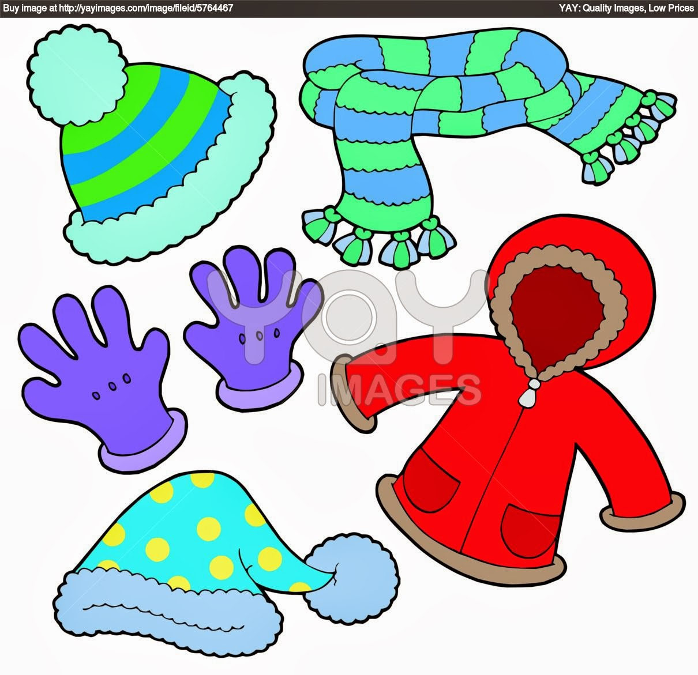

Dates for December

Monday, December 3 -no school PD day

 Friday, December 7 -Bake/Treasure Sale

Thursday, December 13 -K-3 Concert 7 pm

Friday, December 21 -last day until break

Dec. 22-January 6 -winter break

Monday, January 7 -first day back for students

**Learning outcomes for December**   
**Language Arts:**

[](http://www.google.ca/url?sa=i&source=images&cd=&cad=rja&docid=i3K934hyv5sARM&tbnid=yYJgm7632WDPzM:&ved=0CAgQjRw&url=http://www.math-360.com/imo_site/product/curriculum-standards/&ei=ebLIUsXCBqer2QWcuoGACw&psig=AFQjCNFvF4Ae-iqtFm7DKroLfvOKUezYxw&ust=1388971001142857)

-descriptive language writing project: narrative writing style of the author Joanne Ryder

-writing process: pre-planning with graphic organizers, rough drafts and typed final draft

-explicit instruction on making connections reading comprehension strand and connections reading logs

**Math:**

-grade 4: addition and subtraction

-grade 5: decimal place value and addition of decimals

**Science: Properties and Changes of Materials**

-states of matter, processes that affect changes in the properties and lab experiments

**Social Studies: Dynamic Relationships**

-grade 4: the geography, landscapes, political boundaries, landforms, and regional symbols of Saskatchewan

-grade 5: the geography, landscapes, political boundaries, landforms, and regional symbols of Canada

**Health: Wellness**

-balancing spiritual, mental, emotional and physical health and well being

**Art Education: Elements of Dance**

-types of dances and how they use the elements



If you need to contact me, please email me at [cumingc@spsd.sk.ca](mailto:cumingc@spsd.sk.ca)

Check out the blog at <http://www.cuming-klassenclassroom.com/>

Best regards,

Coralee Cuming