Lab# Observing Rocks Found in Our Community
Name & Partners: Date:

Purpose: To observe, compare and describe the properties of each rock and to identify whether they are igneous, sedimentary or metamorphic rocks.

Hypothesis: I predict that the three rocks I found are: 1.____________________2,________________ 3._______________

Materials:
-3 rocks from school yard -pencil
-magnifying glass -colouring tools
-resources text or computers

Procedures:
- Collect 3 different looking rocks from our school playground
- Document where you found them and their purpose (décor, landscaping, part of soil, playground structure etc)
- Illustrate and describe the features and properties: describe in sentences the appearance of each of the rocks: shape, colour, texture, crystal shape, size, texture and dullness or shininess.
- Predict a classification of what kind of rock it would be igneous, metamorphic, or sedimentary rock.
- Explain your hypothesis (striations or layers, smooth, jagged or fractures, colours or shapes) for rock type
- Complete the table and research either computer or textbook to see if your prediction is correct.
- Refer back to your hypothesis and in your conclusion restate whether your prediction was correct

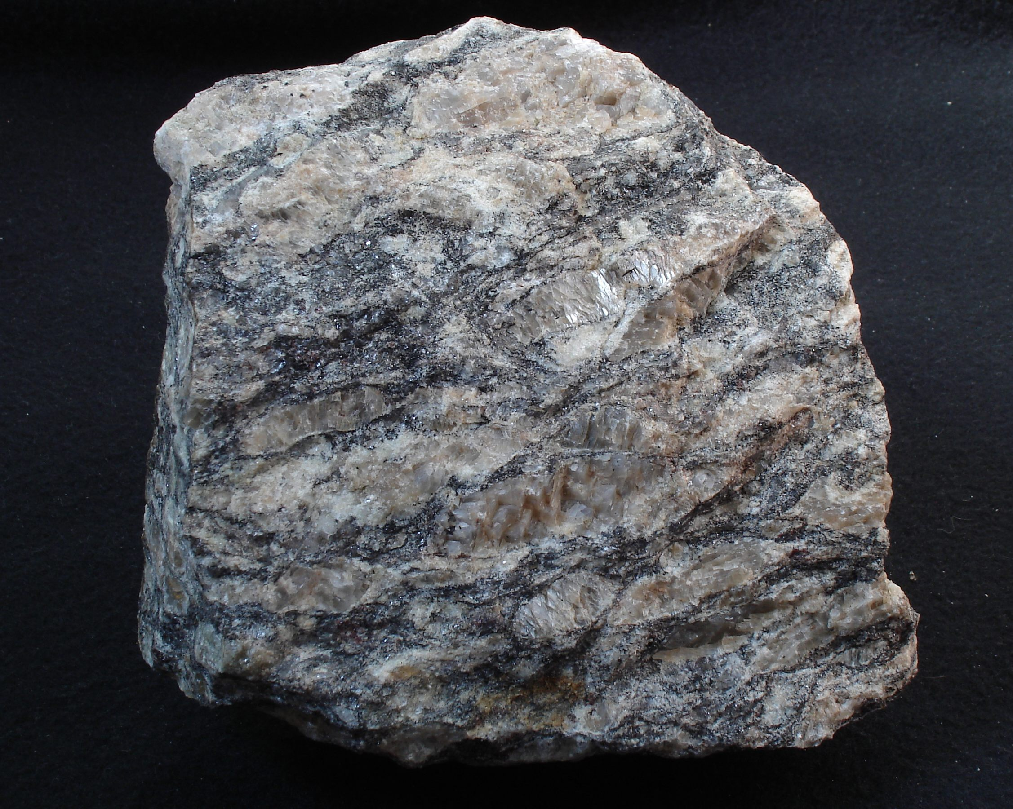
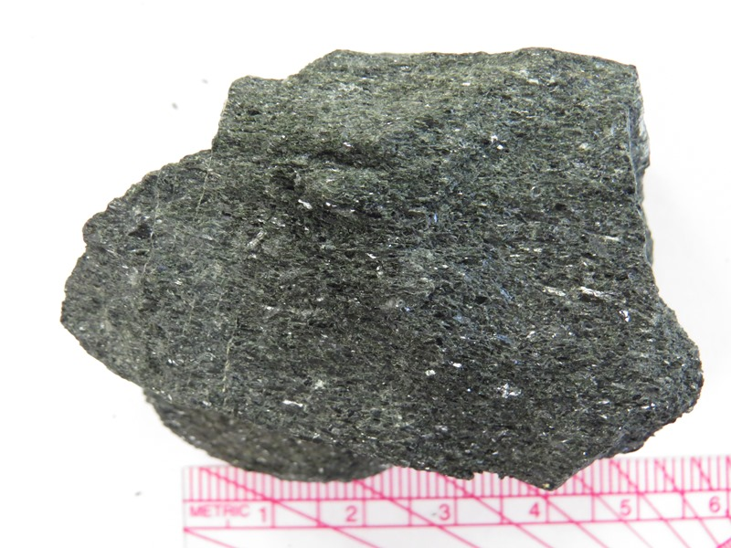
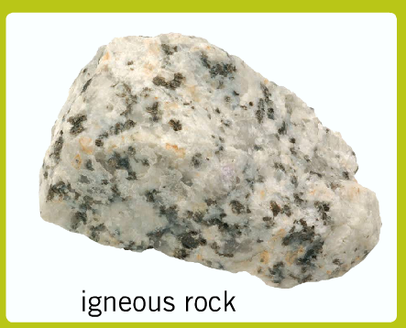

Metamorphic rock
Sedimentary rock
Igneous rock
Observations: document and fill out the table

 | Rock 1 | Rock 2 | Rock 3
Illustrate,
draw, and colour

Describe properties:
size, shape, texture, luster features, etc

location where was it found & what used for

Predict: igneous, sedimentary or metamorphic Why?

Check: prediction correct?
√ or X
Conclusion:

_________________________________________________________________________________________________________________________________________________________________________________________________________________________________________________________________________________________________________________________________________________________

